1. Implement an ArrayDequeue and all of its methods such as add(), addFirst(), addLast(), element(), poll(), push(), remove.

**package** SBA_3;

**import** java.util.ArrayDeque;

**public** **class** Q1 {

**public** **static** **void** main(String[] args) {

ArrayDeque<String> animals = **new** ArrayDeque<>();

// Using add()

animals.add("Dog");

// Using addFirst()

animals.addFirst("Cat");

// Using addLast()

animals.addLast("Horse");

System.***out***.println("ArrayDeque: " + animals);

// Using poll()

String element = animals.poll();

System.***out***.println("Removed Element: " + element);

System.***out***.println("New ArrayDeque: " + animals);

// Using pollFirst()

String firstElement = animals.pollFirst();

System.***out***.println("Removed First Element: " + firstElement);

// Using pollLast()

String lastElement = animals.pollLast();

System.***out***.println("Removed Last Element: " + lastElement);

// using push()

animals.push("Rabbit");

animals.push("cow");

animals.push("goat");

System.***out***.println("After push method ArrayDeque: " + animals);

// using element()--returns element present in the head

System.***out***.println("Head element by element() method: " +animals.element());

// Using remove()

String element1 = animals.remove();

System.***out***.println("Removed Element: " + element1);

System.***out***.println("New ArrayDeque: " + animals);

// Using removeFirst()

String firstElement1 = animals.removeFirst();

System.***out***.println("Removed First Element: " + firstElement1);

// Using removeLast()

String lastElement1 = animals.removeLast();

System.***out***.println("Removed Last Element: " + lastElement1);

}

}

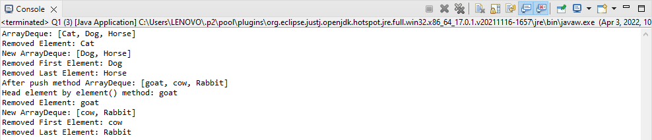

2. Implement a PriorityQueue and use all the methods.

**package** SBA_3;

**import** java.util.Iterator;

**import** java.util.PriorityQueue;

**public** **class** Q2 {

// Main Method

**public** **static** **void** main(String args[])

{

PriorityQueue<String> pq = **new** PriorityQueue<>();

pq.add("Ajay");//A-Z= 65-90

pq.add("Vijay");

pq.add("Raj");

pq.add("Gagan");

System.out.println("head:"+pq.element());

System.out.println("head:"+pq.peek());

System.out.println("iterating the queue elements:");

Iterator itr=pq.iterator();

**while**(itr.hasNext()){

System.out.println(itr.next());

}

pq.remove();//removes the head element

pq.poll(); //removes the head

System.out.println("after removing two elements:");

Iterator<String> itr2=pq.iterator();

**while**(itr2.hasNext()){

System.out.println(itr2.next());

}

}

}

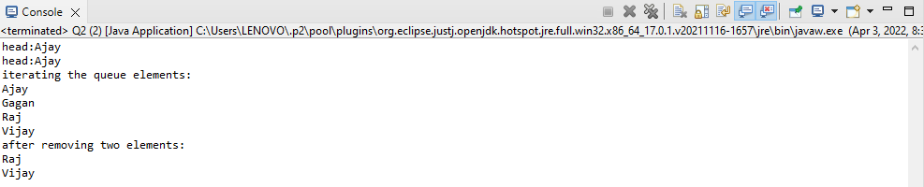

3. Implement a Stack and all of its methods peek(), push(), pop(), and to determine the size of the stack.

//Implement a Stack and all of its methods peek(), push(), pop(), and to determine the size of the stack.

**package** SBA_3;

**import** java.util.Stack;

**public** **class** Q3 {

**public** **static** **void** main(String[] args) {

// Creating an empty Stack

Stack<Integer> stk = **new** Stack<Integer>();

// Use add() method to add elements stk.push(10);

stk.push(15);

stk.push(30);

stk.push(20);

stk.push(5);

// Displaying the Stack

System.***out***.println("Initial Stack: " + stk);

// Removing elements using pop() method

System.***out***.println("Popped element: "+ stk.pop()); System.***out***.println("Popped element: "+ stk.pop());

// Displaying the Stack after pop operation

System.***out***.println("Stack after pop operation "+ stk);

// Fetching the element at the head of the Stack

System.***out***.println("The element at the top of the"+ " stack is: " + stk.peek());

// Displaying the Stack after the Operation

System.***out***.println("Final Stack: " + stk);

// Displaying the size of stack

System.***out***.println("The size is: " + stk.size());

}

}

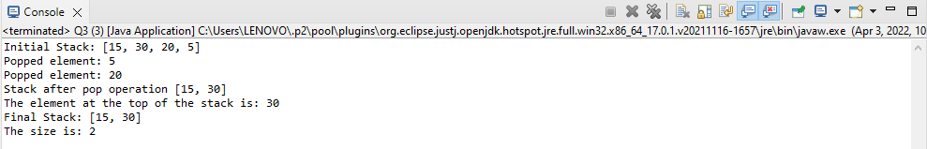

4. Write a program to implement insertion sort.

//Write a program to implement insertion sort.

**package** SBA_3;

**public** **class** Q4 {

/*Function to sort array using insertion sort*/

**void** sort(**int** arr[])

{

**int** n = arr.length;

**for** (**int** i = 1; i < n; ++i) {

**int** key = arr[i];

**int** j = i - 1;

/* Move elements of arr[0..i-1], that are

greater than key, to one position ahead

of their current position */

**while** (j >= 0 && arr[j] > key) {

arr[j + 1] = arr[j];

j = j - 1;

}

arr[j + 1] = key;

}

}

/* A utility function to print array of size n*/

**static** **void** printArray(**int** arr[])

{

**int** n = arr.length;

**for** (**int** i = 0; i < n; ++i)

System.***out***.print(arr[i] + " ");

System.***out***.println();

}

// Driver method

**public** **static** **void** main(String args[])

{

**int** arr[] = { 12, 11, 13, 5, 6 };

Q4 ob = **new** Q4();

ob.sort(arr);

*printArray*(arr);

}

}

